[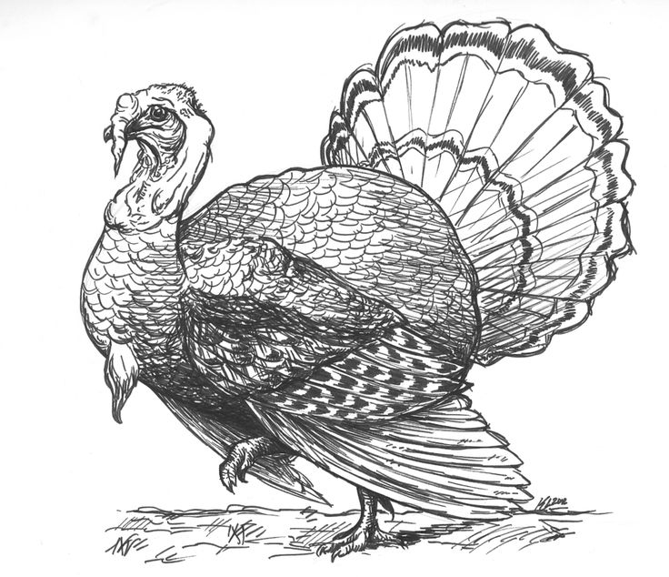](https://www.google.co.uk/url?sa=i&rct=j&q=&esrc=s&source=images&cd=&cad=rja&uact=8&ved=0ahUKEwibhebeyejWAhXCKMAKHYnRDTkQjRwIBw&url=https://www.pinterest.com/vickyscarr/turkey/&psig=AOvVaw2ZRjXA6nU3MRV8F3aAWGOB&ust=1507811508255543)

**Christmas Poultry**

Broomfield’s Farm shop

Established 1910

**Local Bronze Turkey**

White and Bronze turkeys are all sourced from Harry Baylis’s farm near Romsley. Bronze turkeys available between 10lb-20lb

**10 lb + £3.60 per lb** ………………………………………………………………..

**Local White Turkey**

White turkeys available between 10lb-25lb

**10-14lb £3.60 per lb** …………………………………………………………….

**15-18lb £3.40 per lb**………………………………………………………………

19lb + £3.15 **per** lb ………………………………………………………………

**Turkey crown £4.75 per lb** …………………………………………………

**Boned and rolled £7.50 per lb**………………………………………………

**Cockerels**

Whole bird £2.50 per lb ………………………………………………

Cockerel cushion wrapped in bacon and filled with gluten free sage and onion stuffing. Price **£46**

**Duck**

Oven ready duck £9.95 kg **…………………………………..**

**Goodman’s Free-Range Poultry**

Free range goose 8.8 lb- 13lb £4.95 per lb

Free-range turkey 11lb- 18lb £4.45 per lb

Free-range turkey18lb- 22 lb £3.95 per lb

**Sausages and Garnishes**

**Garnish Selection Pack**

12 pigs in blankets, 12 pork sausages and 12 gluten free pork sage and onion stuffing balls £17.50

Pigs in blankets per kg £13.95 ………………………………

Chipolatas £8.25 per kg…………………………………………

Traditional pork sausages £8.25 per kg ……………………

Cocktail sausages £9.50 per kg ………………………………..

Pork sage and onion stuffing £7.50 per kg …………………

Plain sausage meat £7.99 per kg ………………………………………

Cumberland Sausage meat £7.99 per kg …………………………

**Gammon and Bacon**

Smoked gammon £9.99 Per KG ………………………….

Unsmoked gammon £8.99 per KG ………………………

Shropshire back bacon £16.00 per kg ……………………..

Oak smoked back bacon £16.00 per kg …………………..

Streaky bacon £16.00 per kg ………………………………….,

Oak smoked streaky bacon £16.00 per kg ………………

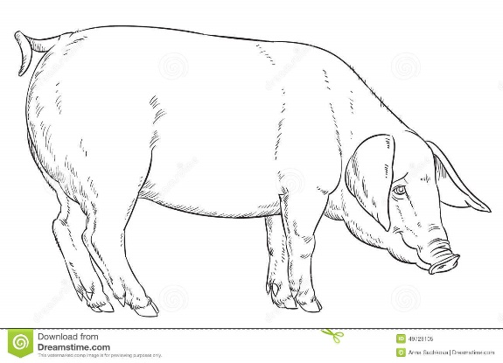

**Locally Reared pork**

**All Broomfields pork is free range and sourced from Rowley Farm which is less than one mile from Broomfields.**

Pork Loin chops £8.50per kg.………………………………………………………………….

Pork Loin joint £8.99 per kg …………………………………………………………………….

Pork shoulder £7.95 per Kg……………………………………………………………………

Pork Leg boned and rolled £8.50 per Kg………………………………………………

.

**Locally Reared Lamb**

**All lambs are raised on Rowley Farm which is less than 1 mile from Broomfields and have been is raised to the highest welfare standards.**

Lamb crown £17.95 per Kg ………………………………………………………

Whole leg of lamb £12.95 per Kg……………………………………………..

Leg of lamb boned and Rolled £14.95 per kg……………………………..

Lamb shoulder boned & rolled £11.45 per Kg ……………………………..

Lamb cutlets £17.95 per Kg……………………………………………………….

Barnsley chops £16.95 per Kg…….……………………………………………

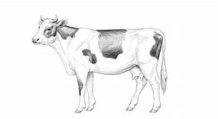

**Locally Reared Pasture Raised Beef**

**The Beef is all reared locally and comes from Lincoln Red Cattle or Hereford cattle. Which have been pasture fed.**

Boneless rolled rib of beef £21.99 per Kg…………………………………………………

Rib of beef (bone in) £18.99 per Kg……………………………………………………….

Rolled sirloin of beef £22.95 per Kg……………………………………………………….

Fillet steak £44.99 per Kg ……………………………………………………………………….

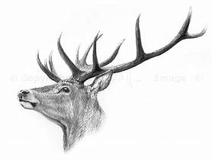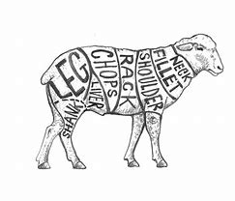

**Wild Venison**

**All of our venison is sourced from the Worcestershire and Shropshire counties.**

Stuffed wild venison haunch, stuffed with a venison, apricot and brandy sausage meat. ( min weight 1kg ) £ 70.00………………………………………………………………………..

Boneless haunch joint 16.95 per Kg……………………………………………………………….

Customer Details

Name:………………………………………………….

Address……………………………………………………

……………………………………………………………….

Contact Number ………………………………………

Collection Date

22nd December Yes/No

23rd December Yes/No

24th December Yes/No

Collections on the 24th must be before 12:00 NoooNoon